

**Adding and Changing Payment Information Directions for Active Suppliers in the City of Fort Worth PeopleSoft Supplier Portal**

* Please use Internet Explorer.
* You can access this page by going to [www.fortworthtexas.gov/purchasing](http://www.fortworthtexas.gov/purchasing) , Supplier Information, then chose Register with the City of Fort Worth.
* This will then take you to a Supplier Public Home Page where you will on Update your information by clicking on the Sign In tile and using your login information to access your supplier account.
* All payment request updates may take 2-3 weeks as the City completes a verification process to ensure accuracy and validity.

**Step 1**

Sign into your account as shown on the screen below with your User ID and password.

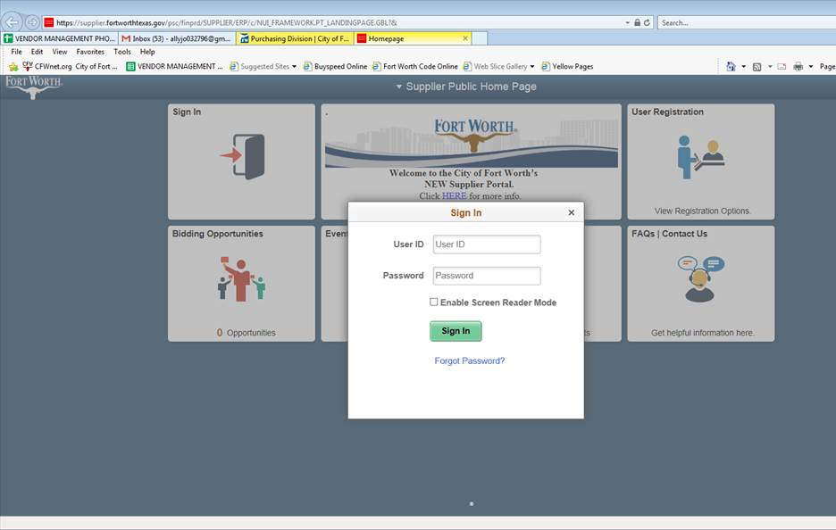

**Step 2**

Click on the “Manage Profile” box on your home screen after you log in.

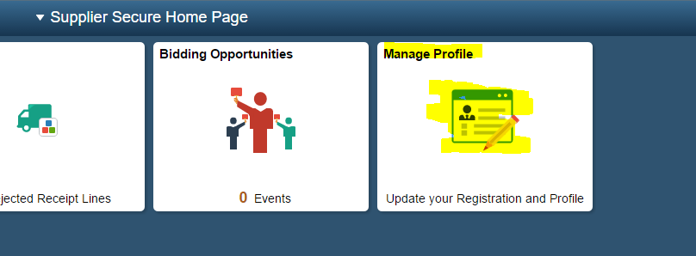

**Step 3**

Click on the “Supplier Change Request” tab on the left side of the screen under the “Manage Profile” section.

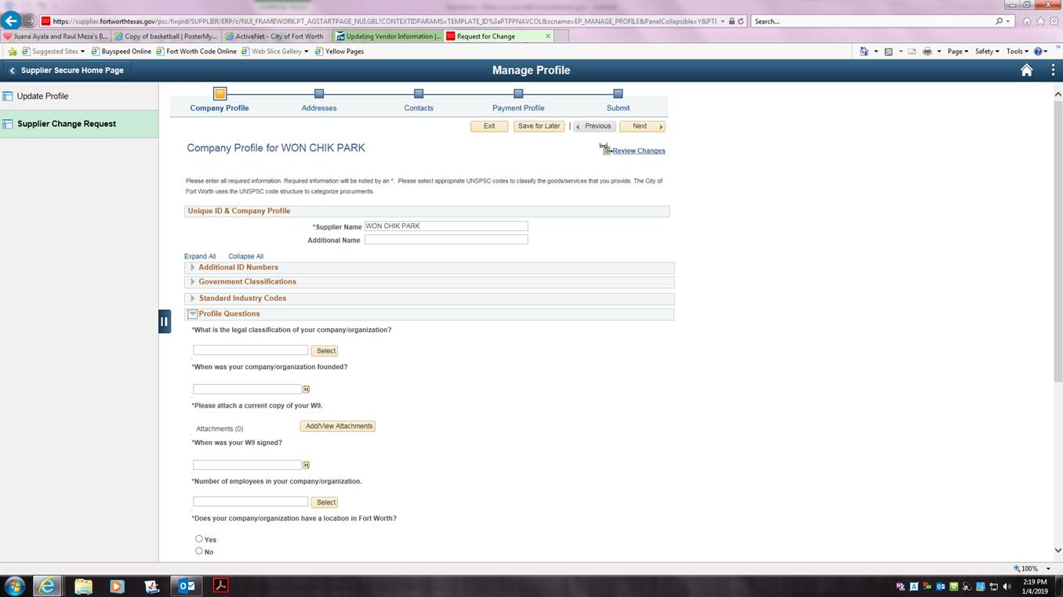

**Step 4**

On the company profile section, click on the grey arrow in front of “Profile Questions”

* The system makes you answer these questions before you can proceed to the next step. You must select answers off of the “Select” button on the right side of the question box or select a date on the “Calendar” button on the right side of the question box.
* You only are required to answer the questions that have a “*” in front of them. Answering questions that do not have a “*” in front of them are optional.
* Please note these questions are for security purposes and to ensure the security of your company’s sensitive information.
* After you have answered the Profile Questions, click the “Next” button on the top right hand corner

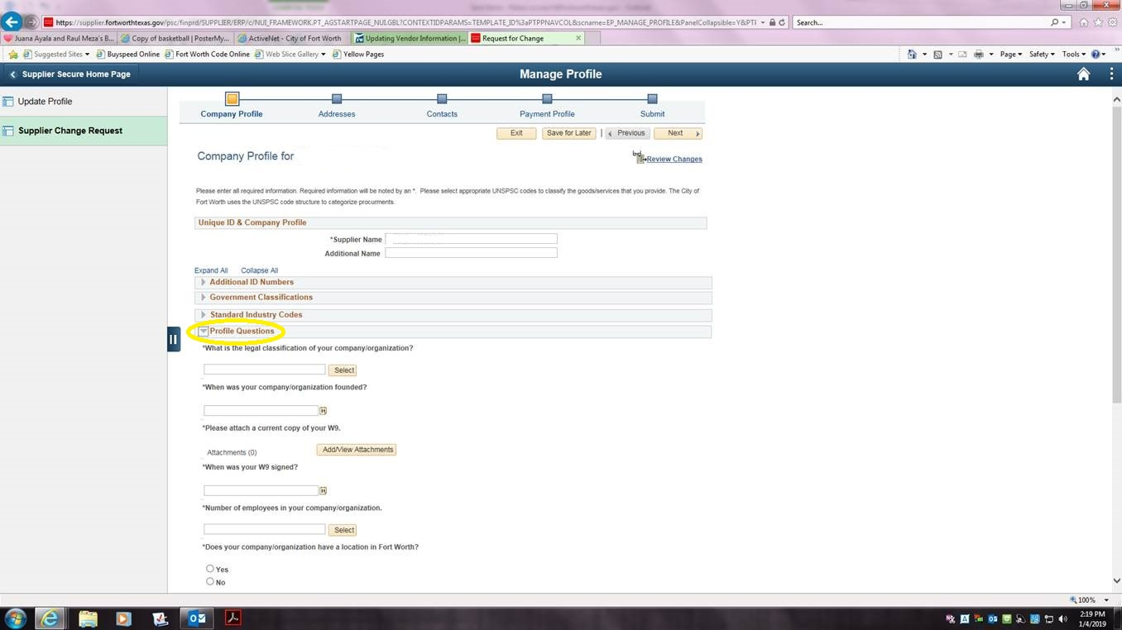

**Step 5**

This step is the “Addresses” portion.

* Please view these addresses to make sure they are updated and correct.
* If you need to change/add an address, please see our adding/changing addresses instructions document.
* After you have viewed the addresses, press the “Next” button on the top right hand corner to proceed to the “Contacts” portion.

**Step 6**

This is the “Contacts” portion. Please view the contacts for your company and then press “Next” on the top right hand corner of the screen to continue to the “Payment Profile” portion.

**Step 7**

This is the Payment Profile Section. This is where you can add a payment method or edit an existing payment method.

* To edit a Payment method, click on the pencil icon by the payment information you are wishing to edit (Remit Check, ACH, etc.)

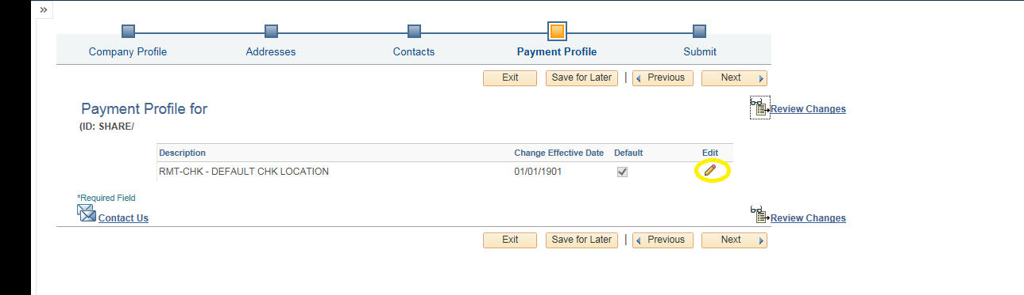

**Step 8**

After you have clicked the “Pencil” icon, this is where you can add or edit a bank account.

* To add a bank account, press the “Add Bank Account” button
* To add a SIC code (Optional): On the left box, select the drop down UNSPSC. On the right box, select the magnify glass and type in the description of your code (what service your company provides).

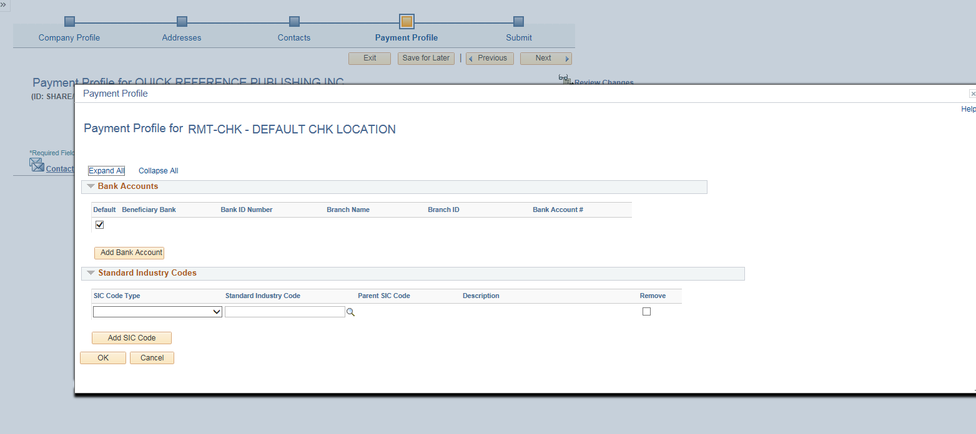

**Step 9**

This is the step for Adding Bank Information. After you click the “Add Bank Account” button you should get a screen shown below.

* All boxes that have a magnify glass beside them, you cannot type in the answer. You will have to click the magnify glass and pick a choice from that list.
* The “Description” box is where you will enter what kind of payment type this is (ACH, Remit Check, etc.)
* Once you have finished entering the bank information, press the “OK” button.

Description (example – ACH, Check)

Bank Name

Bank Id aka Routing number

Bank Accounting Number

Account Type

* Press the “Next” button to proceed to submit your change/information.

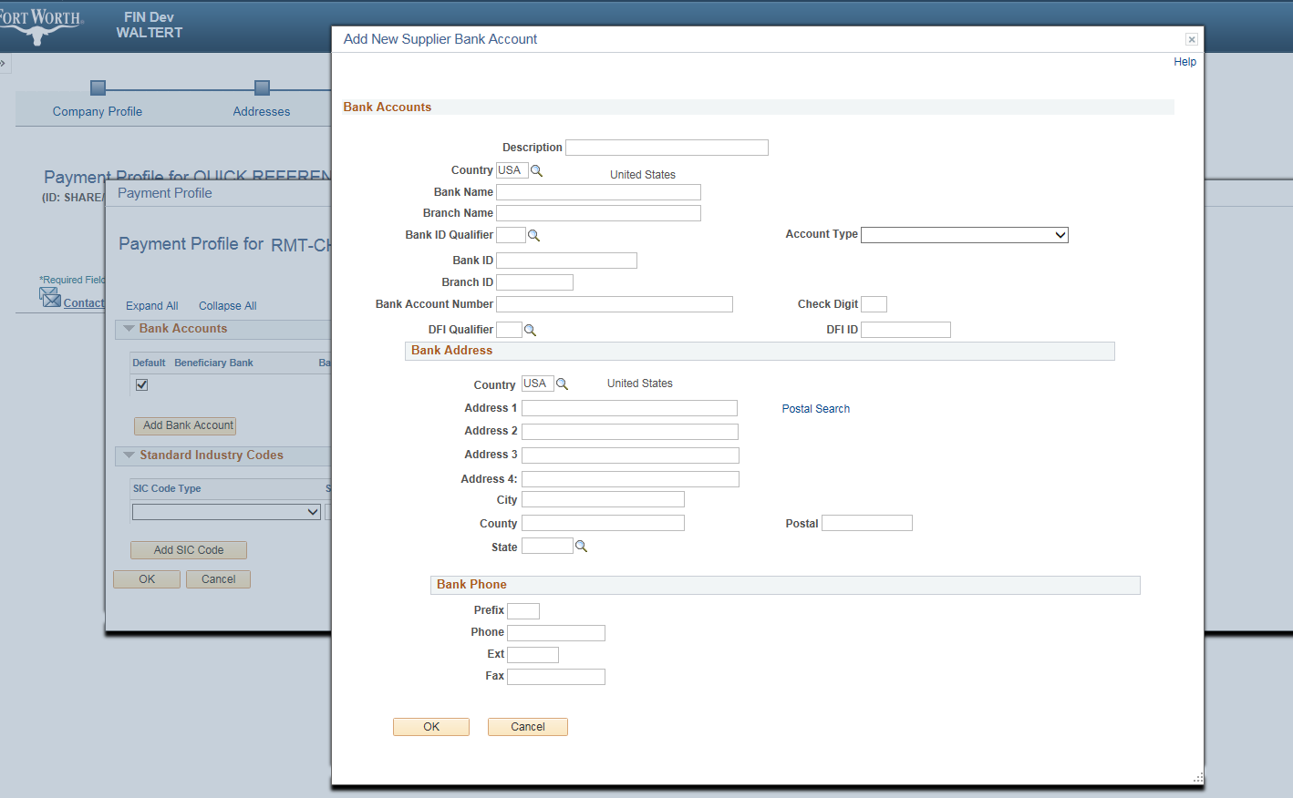

**Step 10**

Submit your address change/Information for approval

* Review/add the email the status of the change will be sent to.
* **Click on the box by “Confirm Changes” before you can proceed to submit your change.**
* Click the “Submit” button to submit your address change/information.

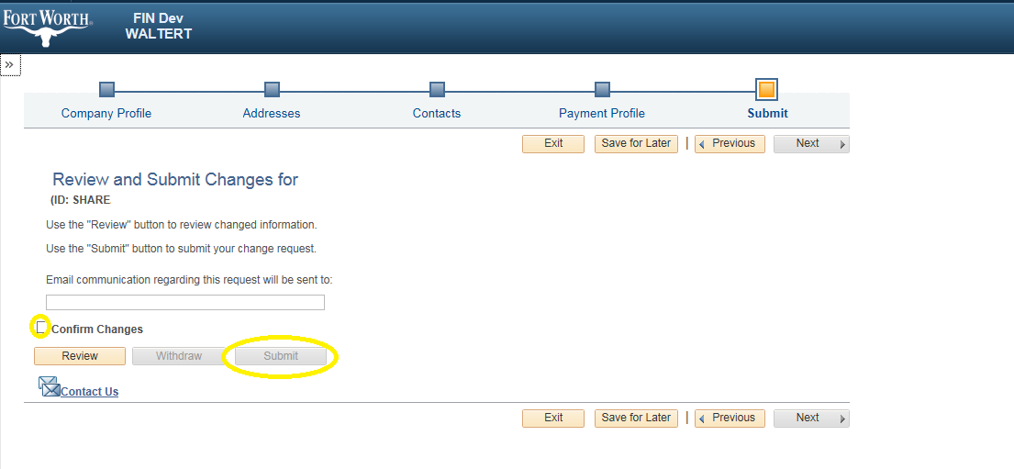

**\*Important Note\***

* Hitting the “Save for Later” button **Does Not** submit your change.
* To continue with the change, complete steps 1-3 where you will see you change pending for approval.
* Click the “pencil” icon on the right side of the date of your change to continue with your change request.

