This Document contains:

Plan Holder Registration Page 1
Plan Holder Registration Instructions Page 2

To the Plan Holder,

By downloading this form to your computer, completing, and emailing to the individuals listed below, you help insure that you are kept up to date of any new information pertaining to this project such as addendums.

Please email this completed document to:

Timothy Welch, P.E.
Welch Engineering, Inc.
Twelch@welcheng.com

AND

George Marquez, City of Fort Worth City of Fort Worth
george.marquez@fortworthtexas.gov

_______________________ Below To Be Completed by Plan Holder _______________________
PLAN HOLDER REGISTRATION

Plan Holder: | Prime
Contact Name: | Sub
Address: | Both
City: | Reprographic Service
State: Zip: | Information Service
Phone: | Supplier
Fax:
Email:
Comments:

Plan Holder Registration Instructions

Complete the Registration on page 1 then

1. Click File – Save As, then
2. Change the portion of the file name ‘Plan Holder Name Here’ with your company name, then
3. Save to your computer

See next page
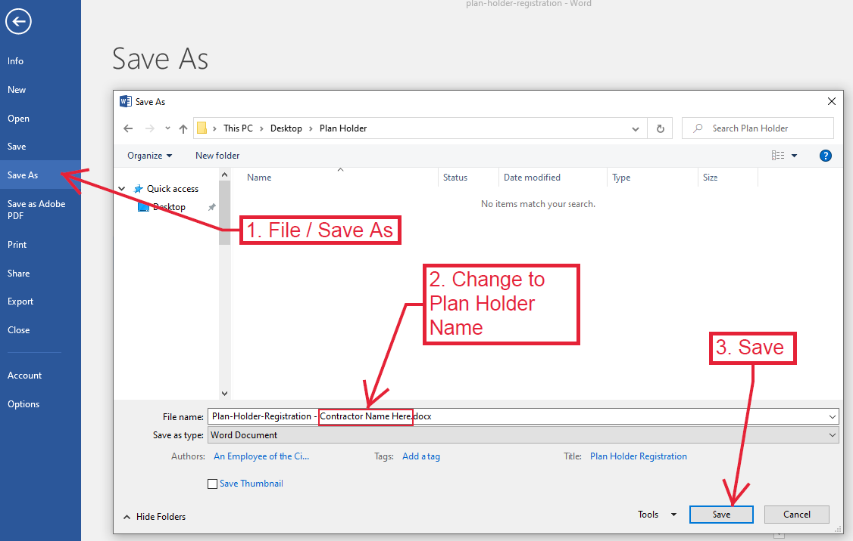

Replace “Plan Holder Name Here” with your Company Name.

